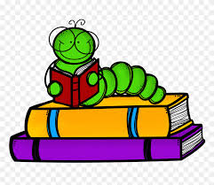
Book Lovers Week

Monday August 10th through Friday August 14th we will be celebrating Book Lovers Week. Please join us in celebrating this week by brining your child’s favorite book to read with their friends!

