

Author Laura Numeroff Week

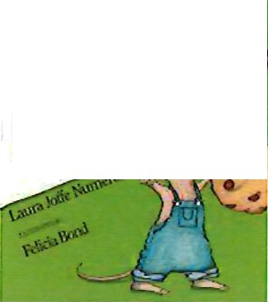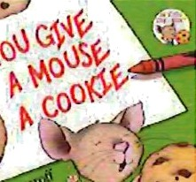

'

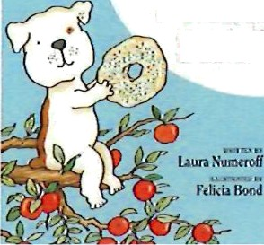

â00G

b0ffUf

The children will celebrate author Laura Numeroff by enjoying special breakfasts, lunches, and snacks during the week of March 3’d thru March 7th!

Monday, March 3rd, 2025:

If You Give A Mouse A Brownie (Snack)

Tuesday, March 4th, 2025:

If You Give A Moose A Muffin (Breakfast)

Wednesday, March Sth, 2025:

If You Give A Mouse A Cookie (Snack)

Thursday, March 6th, 2025:

If You Give A Dog A Donut (Breakfast) If You Give A Cat A Cupcake (Snack)

Friday, March 7th, 2025:

If You Give A Pig A Pancake (Lunch)